All essays have three main components: an introduction, body, and conclusion.
Introduction: The purposes of an introduction is to get your readers attention, to inform the reader of your topic, and to declare your thesis statement.
The Hook: When writing an introduction, you want to intrigue your audience enough to continue reading. The following is a list of devices that are commonly used to begin essays and capture the readers' attention.
• A humorous or fascinating anecdote or short and amusing or interesting story about a real incident or person
• A captivating quotation
• A surprising fact or statistic
• A remarkable statement
The Format: All in all, the introduction should lead logically from the hook to the thesis. Remember, introduction information should include any background or basic information that a reader may need in order to understand the following paragraphs. Remember, your reader does not understand the context of the essay which you have been working with for weeks. Think like your reader; put yourself in their shoes. As a novice to this subject, what might the reader need to understand in order to best understand your essay?
Conclusion The conclusion is the last paragraph of your paper. NEVER add new ideas to your conclusion! The purposes of this paragraph are to leave the reader with a lasting impression, to make the essay feel complete, and to emphasize the significance of the thesis statement. The goal of a concluding paragraph is make the reader continue contemplating the essay after reading it.
Symbolically speaking: The introduction and conclusion symbolize the shape of an hourglass. The introduction starts with a broad hood and synthesizes down to a specific thesis statement. The conclusion, on the other hand, starts with the specific idea of your essay and develop s the idea in a larger context, finalizing any necessary ideas or concepts.
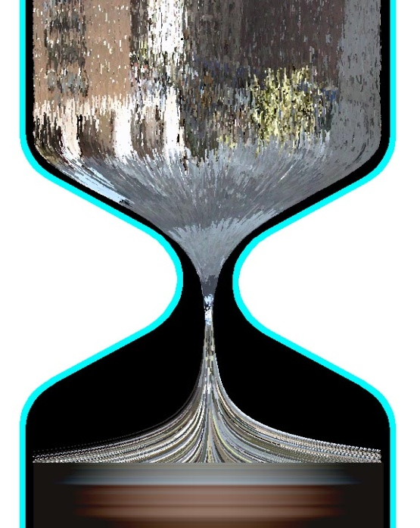

Advice to Youth
by Mark Twain (1835-1910)
Novelist Mark Twain, the author of The Adventures of Tom Sawyer (1876) and The Adventures of Huckleberry Finn (1885), is one of America's great humorists and social critics. In "Advice to Youth," a talk he delivered to a group of young girls, Twain turns the conventional moral lecture on its head.
Being told I would be expected to talk here, I inquired what sort of talk I ought to make. They said it should be something suitable to youth--something didactic, instructive, or something in the nature of good advice. Very well. I have a few things in my mind which I have often longed to say for the instruction of the young; for it is in one’s tender early years that such things will best take root and be most enduring and most valuable. First, then. I will say to you my young friends--and I say it beseechingly, urgingly--Always obey your parents, when they are present. This is the best policy in the long run, because if you don’t, they will make you. Most parents think they know better than you do, and you can generally make more by humoring that superstition than you can by acting on your own better judgment.
There are many sorts of books; but good ones are the sort for the young to read. remember that. They are a great, an inestimable, and unspeakable means of improvement. Therefore be careful in your selection, my young friends; be very careful; confine yourselves exclusively to Robertson’s Sermons, Baxter’s Saint’s Rest, The Innocents Abroad, and works of that kind.But I have said enough. I hope you will treasure up the instructions which I have given you, and make them a guide to your feet and a light to your understanding. Build your character thoughtfully and painstakingly upon these precepts, and by and by, when you have got it built, you will be surprised and gratified to see how nicely and sharply it resembles everybody else’s.
(1882)
In an essay first published in 1786, American statesman and scientist Benjamin Franklin (1706-1790) offers advice on "preserving health" and avoiding "unpleasing dreams." Consider which of Franklin's recommendations may still be worth heeding in our own time.

The Art of Procuring Pleasant Dreams
by Benjamin Franklin (1706-1790)
As a great part of our life is spent in sleep, during which we have sometimes pleasant and sometimes painful dreams, it becomes of some consequence to obtain the one kind and avoid the other; for whether real or imaginary, pain is pain and pleasure is pleasure. If we can sleep without dreaming, it is well that painful dreams are avoided. If, while we sleep, we can have any pleasant dreams, it is, as the French say, autant de gagné, so much added to the pleasure of life.
One or two observations more will conclude this little piece. Care must be taken, when you lie down, to dispose your pillow so as to suit your manner of placing your head and to be perfectly easy; then place your limbs so as not to bear inconveniently hard upon one another, as, for instance, the joints of your ankles; for though a bad position may at first give but little pain and be hardly noticed, yet a continuance will render it less tolerable, and the uneasiness may come on while you are asleep and disturb your imagination. These are the rules of the art. But though they will generally prove effectual in producing the end intended, there is a case in which the most punctual observance of them will be totally fruitless. I need not mention the case to you, my dear friend; but my account of the art would be imperfect without it. The case is when the person who desires to have pleasant dreams has not taken care to preserve, what is necessary above all things,
A GOOD CONSCIENCE.

